|  |
| --- |
| **PROJECT REPORT ON**  **LIBRARY MANGEMENT SYSTEM** |
| C:\Users\Shree\Downloads\cdac atc logo!.png |
|  |
| Library Management System |
|  |
|  |

**Projected Guide: Submitted By:**

**Mrs.Prajkta Patil Mrs.Puja Ravindra Bansode**

**Mr. Bhanu Sir**

**CDAC Advanced Computing Training School, ATC NETCOM , Jaipur , Rajsthan**

|  |
| --- |
|  |

**INDEX**

1. **INTRODUCTION** -------------------------------------------------------------------------------------------------------------------- **1**

1. **PROJECT FEATURES** -------------------------------------------------------------------------------------------------------**3**
2. **PURPOSE----------------------------------------------------------------------------------------------------------- 3**
3. **FEASIBILITY AND SOFTWARE REQUIREMENT** ---------------------------------------------------------------- **5**
4. **DATABASE DESCRIPTION -------------------------------------------------------------------------------------- 9**
5. **USER INTERFACES ---------------------------------------------------------------------------------------------- 11**
6. **TESTING ------------------------------------------------------------------------------------------------------------- 20**
7. **FEATURE ENHANCEMENT ----------------------------------------------------------------------------------- 23**
8. **CONCLUSION ------------------------------------------------------------------------------------------------------ 24**
9. **BIBLIOGRAPHY -------------------------------------------------------------------------------------------------- 25**

**CDAC ADVANCED COMPUTING TRAINING SCHOOL**

**ATC NETCOM , JAIPUR RAJSTHAN**

**PROJECT REPORT**

**ON**

**LIBRARY MANAGEMENT SYSTEM**

**Submitted in Partial fulfillment for the award of Post Graduate**

**Diploma in Advanced Computing**



**Project Guide: Submitted By:**

**Mrs. Prajakta Patil Mrs.Puja Ravindra Bansode**

**Mr, Bhanu Sir**

**CERTIFICATE**

**This is to certify that the project**

**LIBRARY MANAGEMENT SYSTEM**

**Submitted By:-**

**Puja Ravindra Bansode**

**For the Award of Diploma in Advance Computing embodies the bonafied**

**Work done by them under my supervision.**

**Signature of Center Co-ordinator Signature of Center Co-ordinator**

**Mr.Bhanu Sir Mrs. Prajakta Patil**

**ACKOWLEDGEMENT**

We take this occasion to thank God. almightly for blessing us with his grace

and taking our endeavor to a successful culmination. We extend our sincere and heartfelt thanks

to our esteemed guide, **Mrs.Prajakta Patil,** for providingus with the right guidance and advice

at the crucial junctures and for showing me the right way. We also take this opportunity to

express a deep sense of gratitude to our class co-ordinators, **Miss.Suchita** and **Mr.Ajay** for

their cordial support, valuable suggestions and guidance. We extend our sincere thanks to our

respected **Head Of The Division**, for allowing us to use facilities available. We would like to

thank the other faculty members also, as thus occasion. Last but not the least, we would like to

thank our friends and family for the support and encouragement they have given us during the

course of our work

We take this occasion to thank God, almighty for blessing us with his grace and taking

our endeavor to a successful culmination. We extend our sincere and heartfelt thanks to our

esteemed guide, ABC, for providing us with the right guidance and advice at the crucial

junctures and for showing me the right way. We also take this opportunity to express a deep

sense of gratitude to our class coordinators, XYZ and XXX for their cordial support, valuable

suggestions and guidance. We extend our sincere thanks to our respected Head of the division

Name Here, for allowing us to use the facilities available. We would like to thank the other

faculty members also, at this occasion. Last but not the least, we would like to thank our friends

and family for the support and encouragement they have given us during the course of our work

Library Management System

ACKNOWLEDGEMENT

We take this occasion to thank God, almighty for blessing us with his grace and taking

our endeavor to a successful culmination. We extend our sincere and heartfelt thanks to our

esteemed guide, ABC, for providing us with the right guidance and advice at the crucial

junctures and for showing me the right way. We also take this opportunity to express a deep

sense of gratitude to our class coordinators, XYZ and XXX for their cordial support, valuable

suggestions and guidance. We extend our sincere thanks to our respected Head of the division

Name Here, for allowing us to use the facilities available. We would like to thank the other

faculty members also, at this occasion. Last but not the least, we would like to thank our friends

and family for the support and encouragement they have given us during the course of our work.

Library Management System

ACKNOWLEDGEMENT

We take this occasion to thank God, almighty for blessing us with his grace and taking

our endeavor to a successful culmination. We extend our sincere and heartfelt thanks to our

esteemed guide, ABC, for providing us with the right guidance and advice at the crucial

junctures and for showing me the right way. We also take this opportunity to express a deep

sense of gratitude to our class coordinators, XYZ and XXX for their cordial support, valuable

suggestions and guidance. We extend our sincere thanks to our respected Head of the division

Name Here, for allowing us to use the facilities available. We would like to thank the other

faculty members also, at this occasion. Last but not the least, we would like to thank our friends

and family for the support and encouragement they have given us during the course of our work.

**ABSTRACT**

Library Management System is a project which aims in developing a computerized system to maintain all the daily work of library. This project has many features which are generally not available in normal library management system like facility of user login and a facility of login.

A library management system is software that is designed to manage all the functions of a library. It helps librarian to maintain the database of new books and the books that are borrowed by members along with their due dates.

A library management system is used to maintain library records. It tracks the records of the number of books in the library, how many books are issued, or how many books have been returned or renewed or late fine charges, etc.

Overall this project of ours is being developed to help the student as well as staff of library to maintain the library in the best way possible and also reduce the human efforts.

**INTRODUCTION**

This gives an overview about the aim, objectives, background and operation environment of the system.

The project aims and objectives that will be achieved after completion of this project. The projects aims and objectives are as follows:

* Book Issue
* Request column for librarian for providing new book
* Return Book
* Login page can find books issued by him/her and date of return.
* A search column to search availability of books.

**PROJECT FEATURES:-**

* **Catalog Management:-** To digitally keep track of what is available in the library.
* **Circulation Management:-**  To track the movement of books.
* **Bar – Coding:-** To give specific identification to each book.
* **Barcode Scanning:-**
* **Library Card:-**

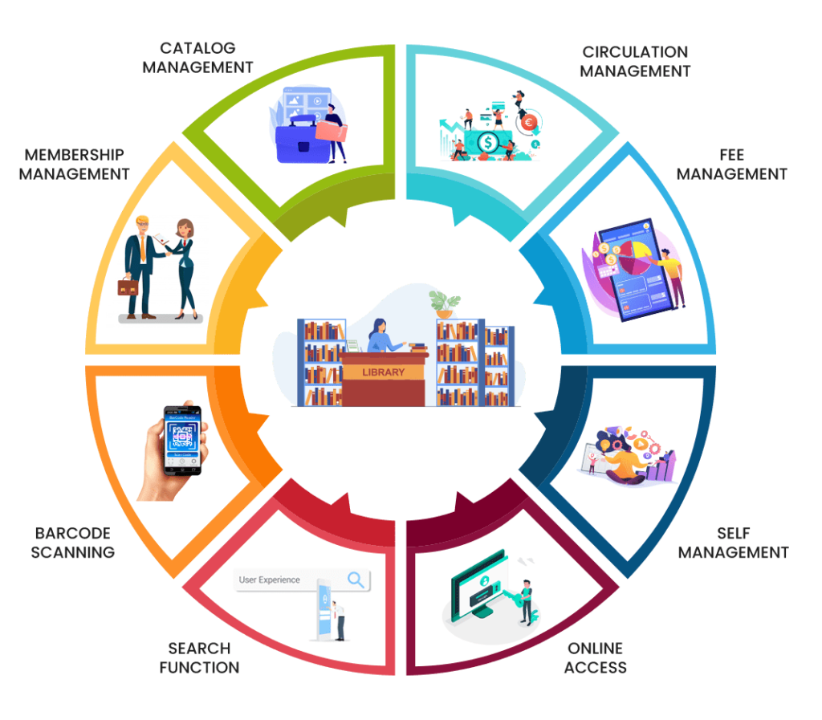

**Features of Library Management System**

**PURPOSE:-**

Library Management System is an application that is helpful for all students, teachers and anyone. A library management system is software that is designed to manage all the functions of a library. It helps librarian to maintain the database of new books and the books that are borrowed by members along with their due dates. This system completely automates all your library’s activities.

The library management system is a software **to manage manual functions of a library**. The software helps to manage the entire library operations from maintaining book records to issue a book.

**FESIBILITY AND SOFTWARE DEVELOPMENT:-**

**Fesibility:-**

It **identifies the problems in the existing system and gives reasons for automation**. The study points out the requirement of library automation and discusses the technical, social and economic aspects of library automation in detail.

Five key areas of a feasibility study are **technical, economic, legal, operational and scheduling**.

**Software Requirement for Development:-**

|  |
| --- |
| OS Platform which supports JDK(JAVA)Like Windows |
| JDK 1.8 |
| Eclips IDE |
| CSS,BOOTSTRAP,JS |
| Jars |
| Tomcat Version 8.5 or above |
| Mysql Version 5.6 or above |

**Hardware Requirement for Development:-**

4 GB of RAM with 20GB HDD.

**DATABASE DESCRIPTION:-**

Mysql database using created a all file and inserted data on that file, using phpmyadmin xampp application.

Screen shorts of inserted data of all files.

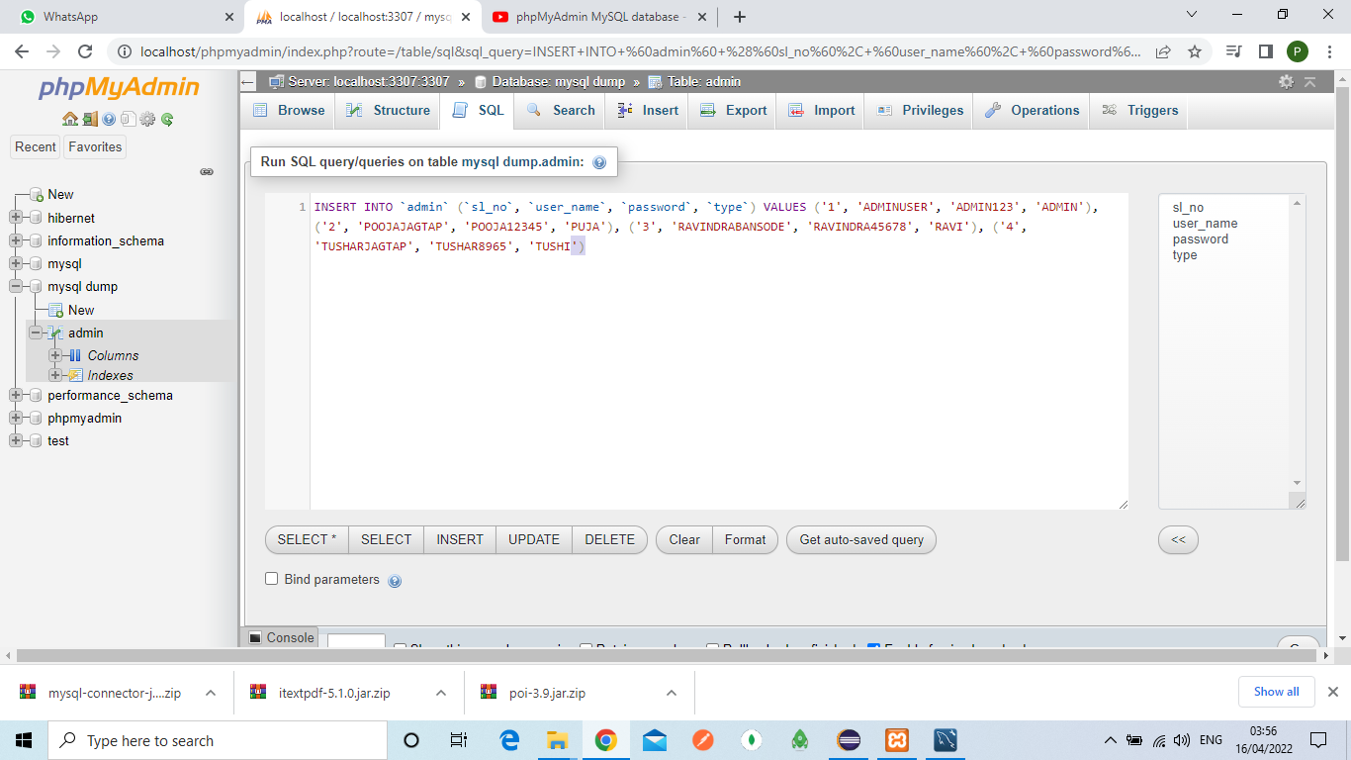

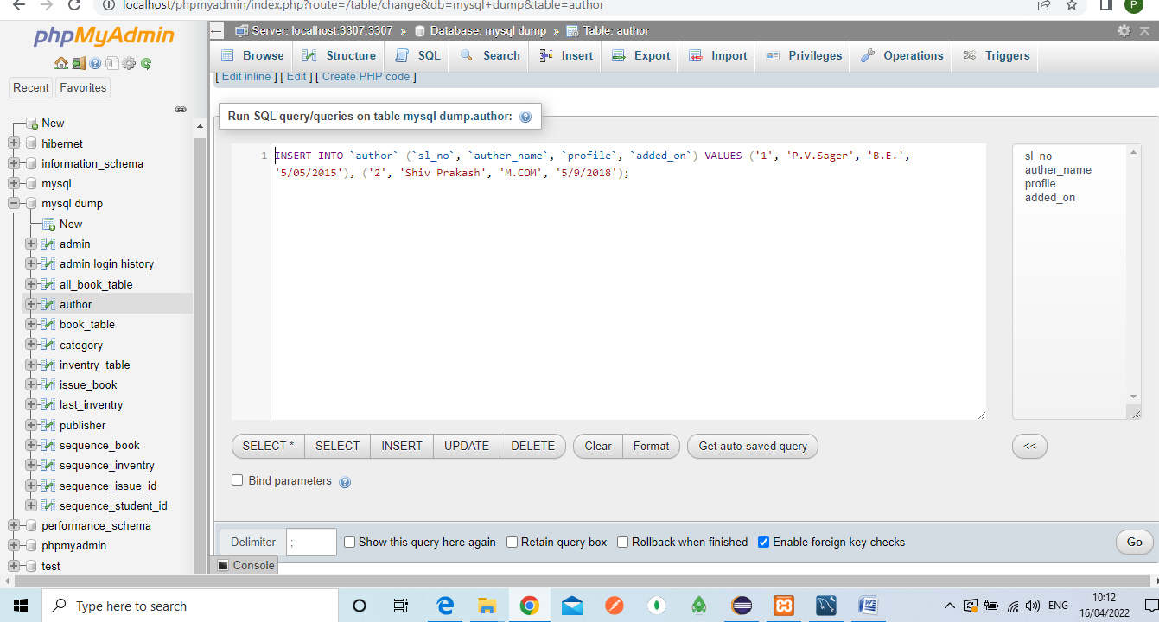

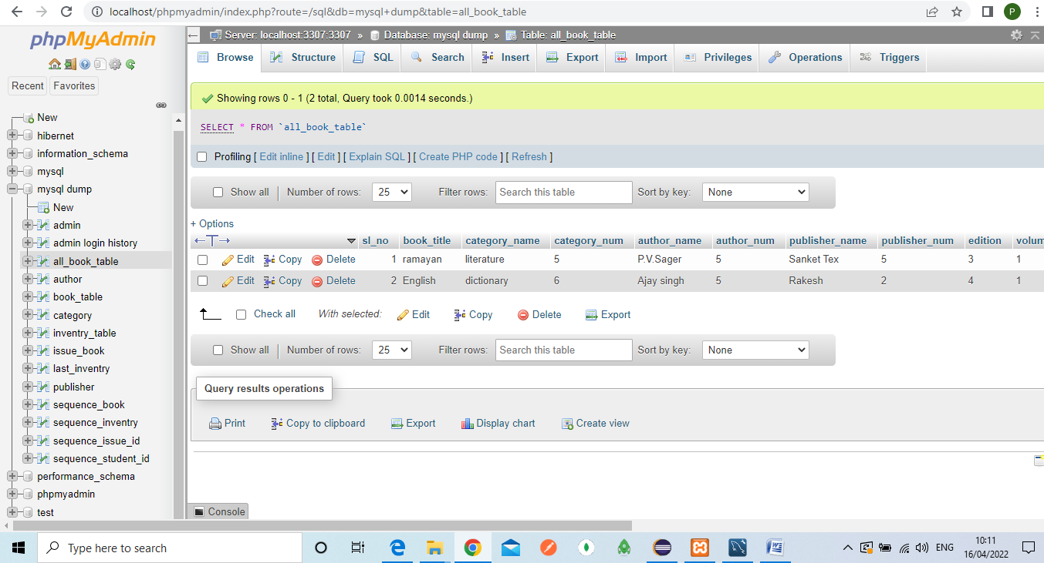

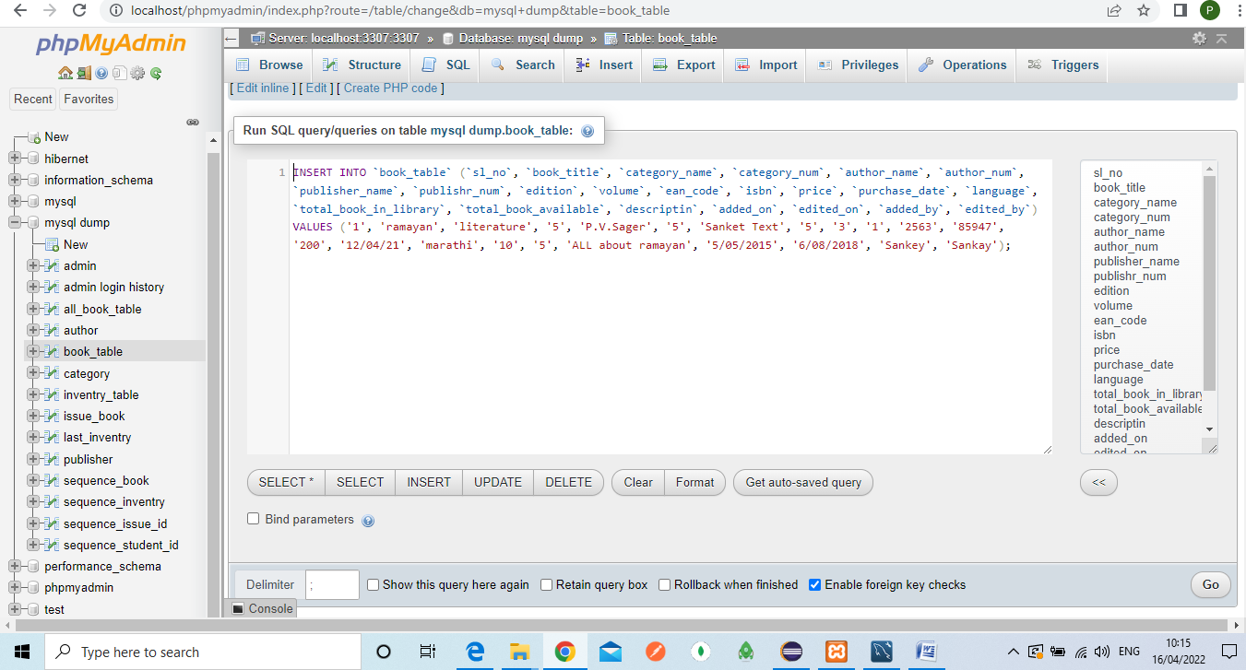

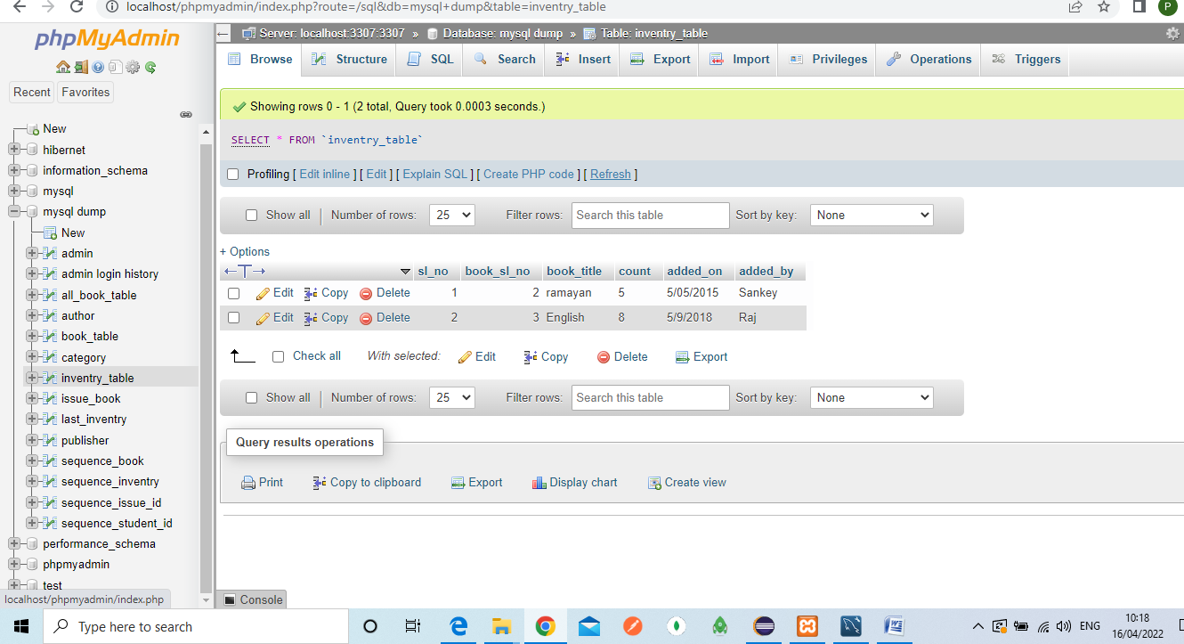

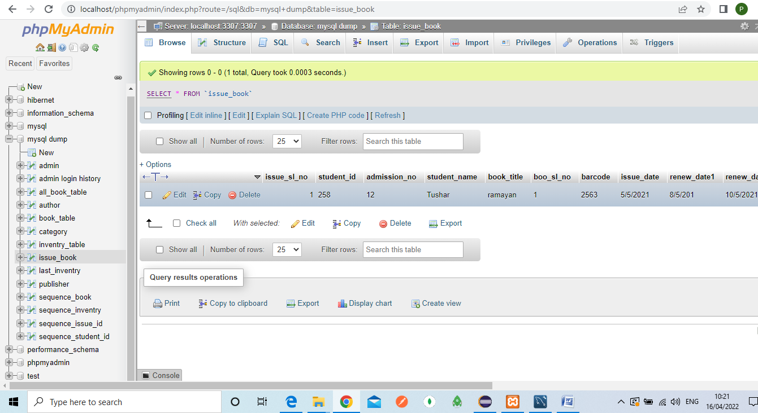

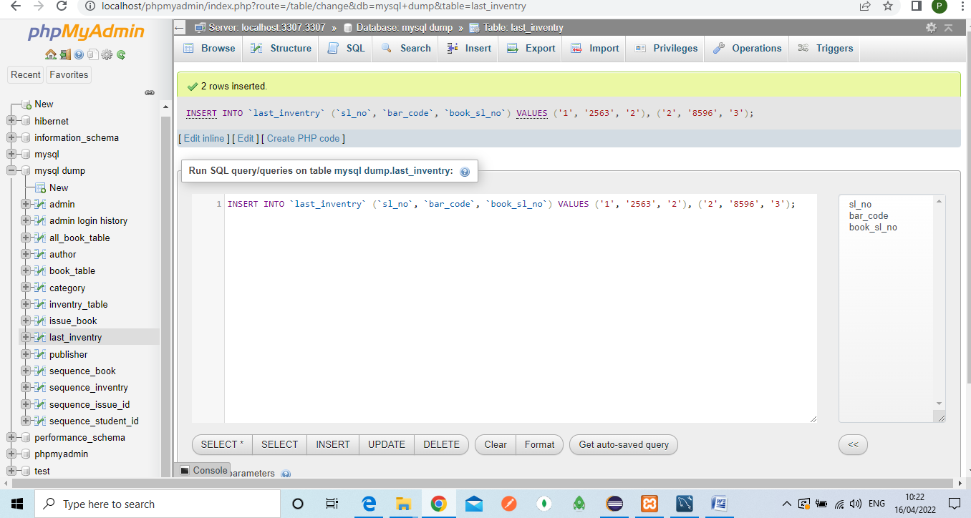

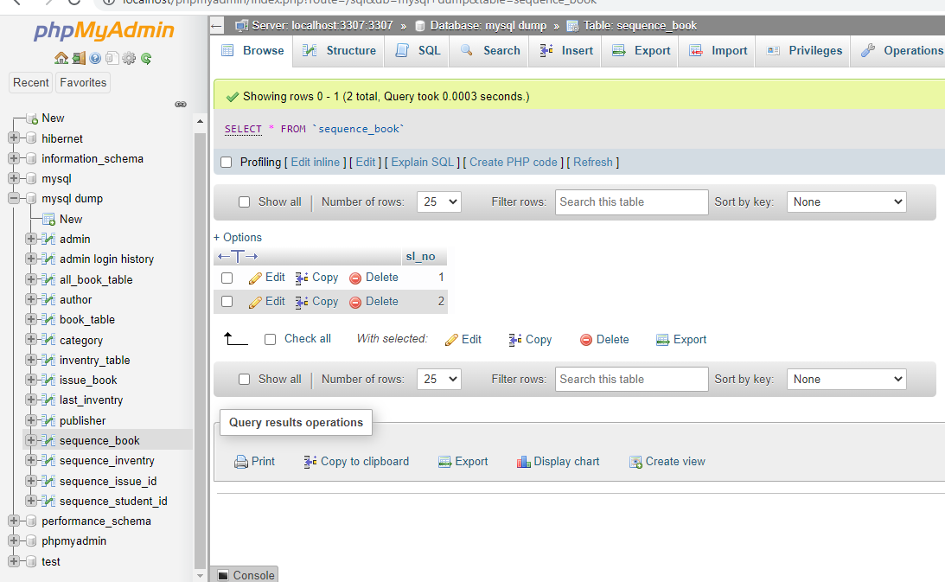 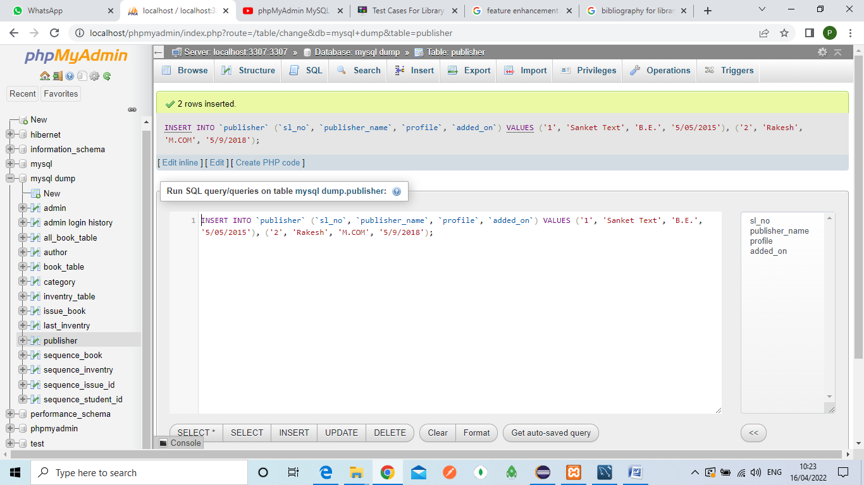

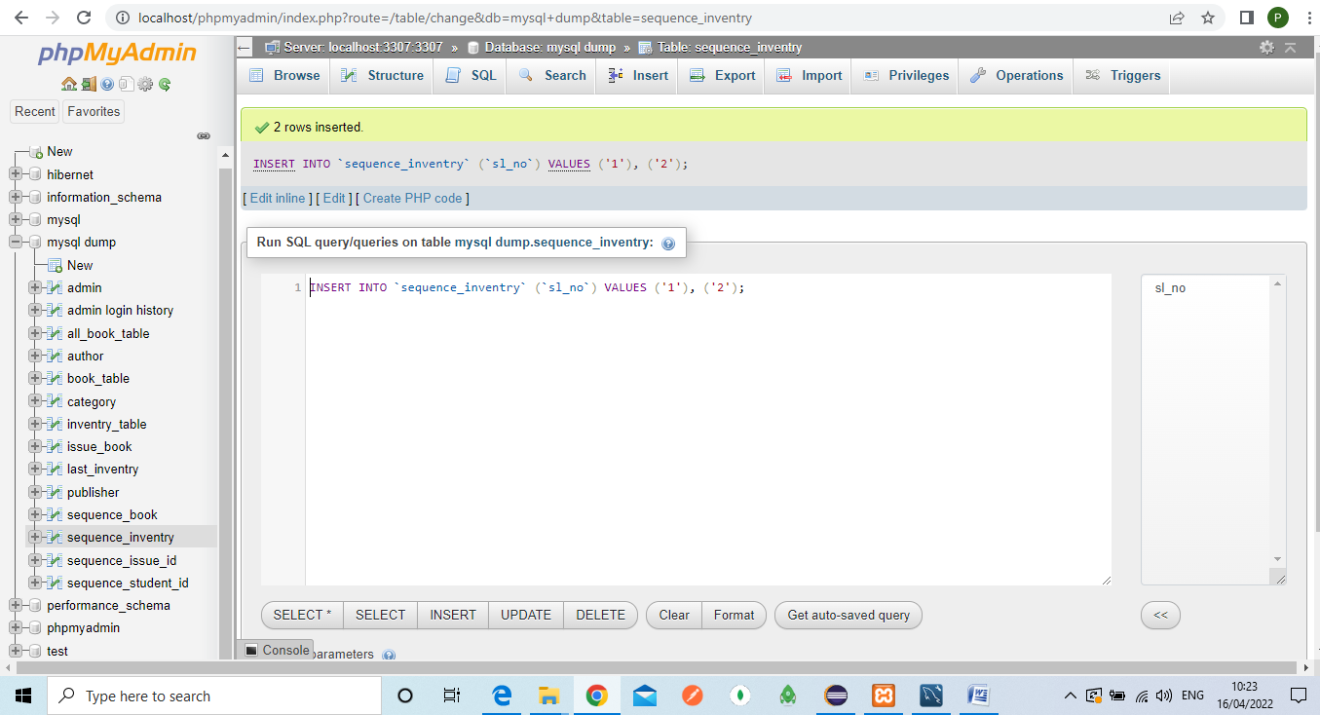

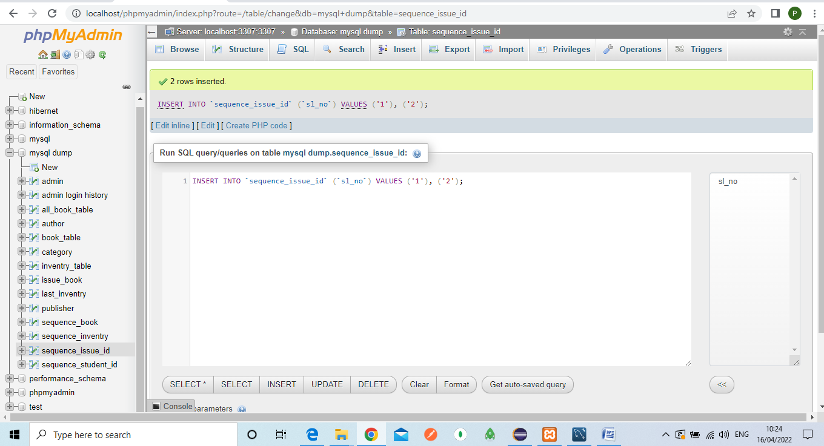

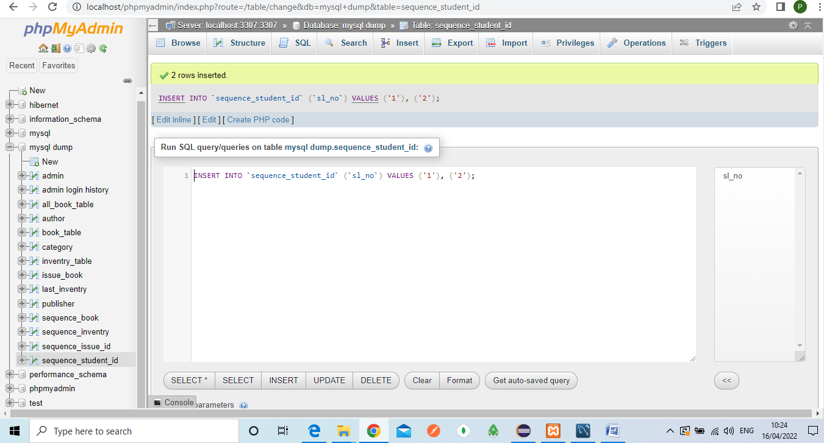

**USER INTERFACES**:-

* Eclips IDE supported for creating whole project.and various file and folder.
* Mysql using for data inserted in phpmyAdmin xampp application.
* Using tomcat server for run the code on browser.
* When data inserted in phpmysql xampp control panel continuously active.

**DFD Diagrams for steps:-**

1.Zero level DFD :-

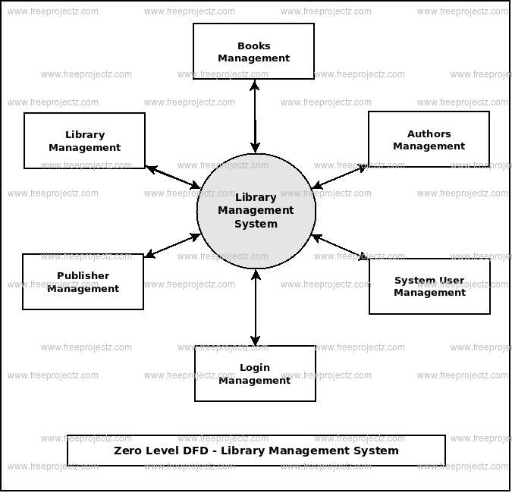

2.First level DFD:-

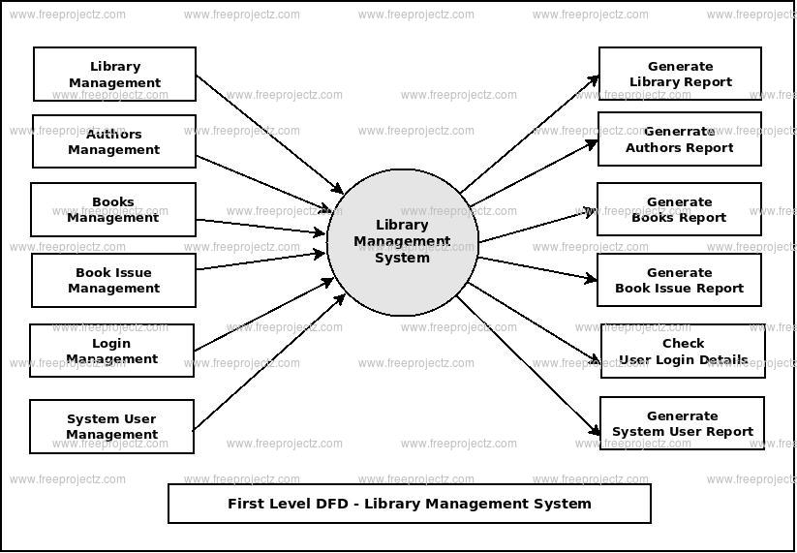

3.Second level DFD:-

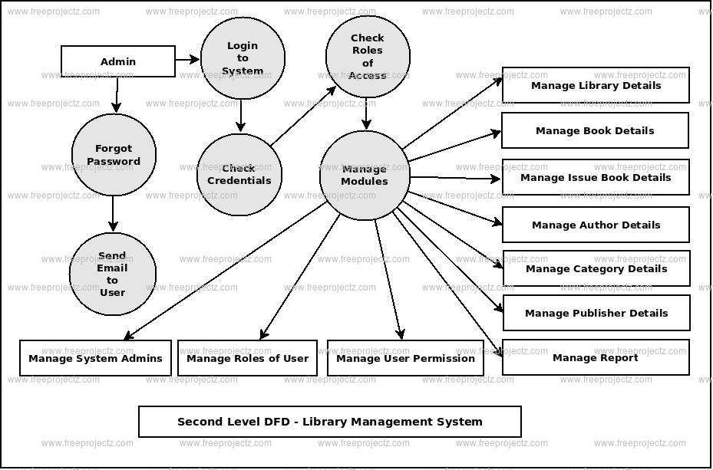

**TESTING**:-

* Test case for Library Management System

**Signing in:-**

|  |  |  |  |
| --- | --- | --- | --- |
| Sl.no | Test Case | Expected result | Test result |
| 1 | Enter name, password and click on sign in button. | Software open the window | Succefully |
| 2 | Enter name, invalid password and click on sign in button | Software not open window | succefully |
| **Add_book:-** |  |  |  |
| Sl.no | Test Case | Expected result | Test result |
| 1 | Enter name of book and other information about book click on add book in button. | BOOK added | Succefully |
|  |  |  |  |
| ISSUE_BOOK |  |  |  |
| Sl.no | Test Case | Expected result | Test result |
| 1 | Search the status of book | Showing in table | Succefully |
| 2 | Search the invalid information in status | Showing invalid data | succefully |
| **RETURN_BOOK** |  |  |  |
| Sl.no | Test Case | Expected result | Test result |
| 1 | Enter name of book and other information about book click on button. | Showing return information in table format | Succefully |
|  |  |  |  |

**USE CASE Diagram:-**

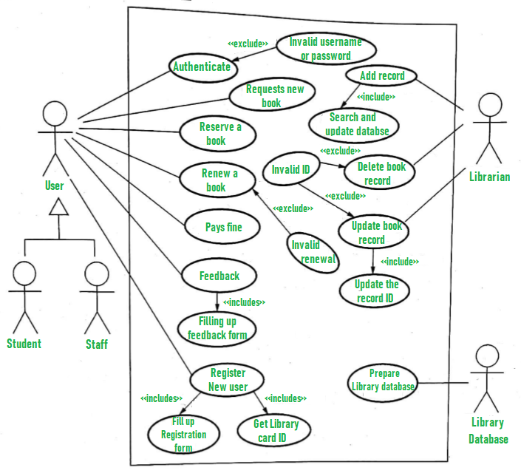

**FEATURE ENHANCEMENT:-**

An ELM was **developed to manage the efficient way of daily book transaction, manage the members and the book records properly**. It has developed by use of Eclipse IDE tool. It helps to improve management of the book property in library. This system is mainly used by librarian and the library admin .

Library management system has been intended to automate, oversee and care for the general handling of even enormous scale libraries. This product is fit for overseeing Book Issues, Returns.

**CONCLUSION:-**

**After we have completed the project we are sure the problems in the existing system would overcome**. The “LIBRARY MANAGEMENT SYSTEM” process made computerized to reduce human errors and to increase the efficiency. The main focus of this project is to lessen human efforts.

**BIBLIOGRAPHY:-**

1. *Sharma, C. K.; Singh, Kiran (2005),*[*Library Management*](https://books.google.com/books?id=T37GFTjlYCoC)*,*[*ISBN*](https://en.wikipedia.org/wiki/ISBN_(identifier))[*978-81-269-0452-5*](https://en.wikipedia.org/wiki/Special:BookSources/978-81-269-0452-5)
2. [**^**](https://en.wikipedia.org/wiki/Library_management#cite_ref-2) *McClure, C. R. (1980). "LIBRARY MANAGERS: Can They Manage? Will They Lead?". Library Journal: 2391.*
3. [**^**](https://en.wikipedia.org/wiki/Library_management#cite_ref-Dewey1_3-0) *Wellish, Hans H. "Dewey Decimal Classification, Universal Decimal Classification, and the Broad System of Ordering: The Evolution of Universal Ordering Systems". College of Library and Information Sciences, University of Maryland. [CiteSeerX](https://en.wikipedia.org/wiki/CiteSeerX_(identifier)" \o "CiteSeerX (identifier))*[*10.1.1.221.3537*](https://citeseerx.ist.psu.edu/viewdoc/summary?doi=10.1.1.221.3537)*.*
4. [**^**](https://en.wikipedia.org/wiki/Library_management#cite_ref-4) *Hawthorne, P (2011). "Succession Planning and Management: A Key Leadership Responsibility Emerges". Texas Library Journal.****87****(1): 8–12.*
5. [**^**](https://en.wikipedia.org/wiki/Library_management#cite_ref-5) [*"ALA | Exhibit Spaces and Bulletin Boards"*](http://www.ala.org/Template.cfm?Section=interpretations&Template=/ContentManagement/ContentDisplay.cfm&ContentID=8538)*. www.ala.org. Retrieved 2016-09-20.*
6. [**^**](https://en.wikipedia.org/wiki/Library_management#cite_ref-6) *Pautz, Hartwig. "Income generation in public libraries: potentials and pitfalls". Library Review.****63****(8/9): 568.*
7. [**^**](https://en.wikipedia.org/wiki/Library_management#cite_ref-7) *Moran, B.; Stueart, R.; Morner, C. (2013). Library and Information Center Management. California: Libraries Unlimited.*[*ISBN*](https://en.wikipedia.org/wiki/ISBN_(identifier))[*978-1-59884-989-9*](https://en.wikipedia.org/wiki/Special:BookSources/978-1-59884-989-9)*.*
8. [**^**](https://en.wikipedia.org/wiki/Library_management#cite_ref-8) [*"Disaster planning"*](https://www.alia.org.au/information-and-resources/disaster-planning)*.*[*Australian Library and Information Association*](https://en.wikipedia.org/wiki/Australian_Library_and_Information_Association)*.*
9. [**^**](https://en.wikipedia.org/wiki/Library_management#cite_ref-9) The [LLAMA website](https://www.ala.org/llama) now points to [Core](https://www.ala.org/core).
10. [**^**](https://en.wikipedia.org/wiki/Library_management#cite_ref-10) [*"The Journal of Library Administration"*](http://www.tandfonline.com/action/journalInformation?show=aimsScope&journalCode=wjla20#.UnvEOBbvxz8)*. Retrieved 7 November 2013.*

**THANK YOU**